Photograph Specification
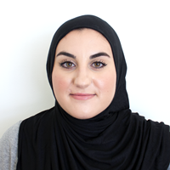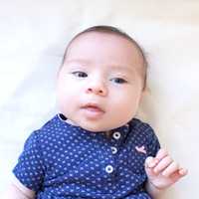
- Color passport photograph with a white background
- 2 inch by 2 inch, fully developed and no shadows
- Identical, eyes open, not smiling, no glasses worn, natural expression, normal clothing
- Taken within the past 6 months, showing current appearance
- Full face, front view – looking directly at the camera
- Measurement: between 1” to 1 3/8” from the bottom of the chin to the top of the head
- Uniforms should not be worn in photographs.
- Do not wear a hat or headgear that obscures the hair or hairline unless for religious purposes.

